Project Name: MuseumDemo

Design Description

Version 1.0

Revision History

Date | Version | Description | Author
2015-02-25 | 1.0 | Final Version | Martin Anev

Table of Contents
1. Introduction 4
1.1 Purpose of this document 4
1.2 Document organization 4
1.3 Intended Audience 4
1.4 Scope 4
1.5 Definitions and acronyms 4
1.5.1 Definitions 4
1.5.2 Acronyms and abbreviations 5
2. Overall description 6
2.1 Project description 6
2.1.1 Interfaces 6
2.1.2 Libraries 6
2.2 Background description 6
2.3 High level description of the domain 6
2.4 Goals and Requirements 7
2.4.1 Goals 7
2.4.2 Requirements 7
3. Software Architecture & Design 8
3.1 Overall Decomposition 8
3.2 Mobile Application Activities 11
3.2.1 ListBeaconsActivity 11
3.2.2 Distance Beacon Activity 12
3.2.3 Metaio Activity 13
3.3 Software Design 14
3.3.1 Design technologies 14
3.3.2 Data flow Diagram 14
References: 15

List of Tables
Table 1. Definitions 5
Table 2. Acronyms and abbreviations 5

List of Figures
Figure 1. General Architecture 8
Figure 2. JSON Template 9
Figure 3. Entity Relationship Diagram Museum Demo 10
Figure 4. List Beacons Activity 11
Figure 5.Distance Beacon Activity 12
Figure 6. Metaio Activity 13
Figure 7. Data Flow Diagram 14

Introduction

Purpose of this document
The purpose of this document is to expose the design decisions of the project delivered by Martin Anev in the Design and Implementation of Mobile Applications course done in ‘Politecnico di Milano’.

Document organization
The document is organized as follows:

- Section 1, Introduction
- Section 2, Overall Description, describes different interfaces and high-level description of the domain
- Section 3, Software Architecture and Design

Intended Audience
The intended audience is:
- The customer of the project
- The supervisor of the project
- All related stakeholders
- Any developer with interest to continue or improve the project

Scope
The document reveals what the description of the design is. It contains information about the following aspects of the design of the project:
- Background and high-level description
- Software architecture, including conceptual design and system specification.
- External interfaces, including hardware, software and user interfaces.
- Detailed software design, including modules, data flows.

Definitions and acronyms

Definitions
Basic definitions of the document terms are defined in Table 1.

Definitions
Keyword | Definitions
iBeacon | An iBeacon is Apple's implementation of Bluetooth low-energy (BLE) wireless technology to create a different way of providing location-based data.
Augmented Reality | Augmented reality is a live direct or indirect view of a physical, real-world environment whose elements are augmented
GitHub | Web-based repository hosting service, which offers all of the distributed revision control and source code management
Table 1. Definitions

Acronyms and abbreviations

Acronyms and abbreviations
Acronym or  abbreviation | Definitions
JSON | Java Script Object Notation (data interchange format)
AR | Augmented Reality
SDK | Software Development Kit
Table 2. Acronyms and abbreviations

Overall description
This section describes the project, background description, high-level descriptions of the domain, goals and requirements of the project. These descriptions provide background knowledge for specifying the design and architecture of the software in the next sections of the document.

Project description
The project has two aims:
- Combine the existing technologies of iBeacons and Augmented Reality.
- Provide demo mobile application with the technologies with museum context
A deliverable of the project is software product. Product’s name is “Museum Demo”. Providing experience that combines iBeacons and Augmented reality.

Interfaces
- External interfaces – The software product does not provide any external interfaces.
- User interfaces - The user interfaces are all in the context of the mobile application

Hardware interfaces – The software product is dependent on Estimote’s iBeacon hardware device for connection.

Software interfaces – The software product is dependent on server connection that contains the needed asset files for the augmented reality and user interface.

Libraries
The product uses two main libraries:

Estimote
The Estimote SDK (Changelog 0.4.3)[1] is providing basic functionalities for connecting to Estimote’s iBeacons physical devices.

Metaio
The Metaio SDK (v.6.0.1) [2] is providing functionalities for Augmented Reality part.

All of the libraries and dependant needed files are included in the repository of the project [3].

Background description
Luca Lamorte (luca.lamorte@telecomitalia.it) is the client and supervisor of the project. He proposed the topic and the aims and has provided general supervision and guidance for the project. The aim is to combine the iBeacon technology with Augmented reality so that when a user using the application goes close to the beacon, an augmented reality activity will be started. The project was proposed to be developed on Android OS.

High level description of the domain
The software product is providing a demo for a possible application for museum that could explain an exponat inside a museum or increase the experience by providing augmented reality models, videos or text.
In proximity to the exponats in the museum are attached iBeacons. At first the user sees on the mobile application the exponats and the estimated location at which they are located. The user chooses an exponats from the provided list and an interactive navigation (in distance) is provided to user so that he approaches the exponats. When the user is inside the set region, the augmented reality activity is started and the user could interact with it.

Goals and Requirements
This part describes the goals and functional requirements that affect the software and their correlation.

Goals
In this part are discussed the general goals of the project.

[G1] Allow users to see list of two or more iBeacons.
[G2] Allow users to understand how far they are from the iBeacons.
[G3] Provide the users with interactive way to reach selected iBeacon.
[G4] Provide Augmented Reality models related to the iBeacons.

Requirements
The following part discusses the functional requirements needed to satisfy the goals.

[FR1] The guidance for the beacons location should be persistent – only the guidance for the selected beacon should be provided.
[FR2] Scalability should be ensured. The application should be suitable for more than one user and more than one museum.

Software Architecture & Design
This section describes the overall decomposition of the components with their specific designs

Overall Decomposition
The “MuseumDemo” project is composed by a non-trivial Three Tier Architecture represented on Figure 1.

Application Server
Client Part

Mobile Application

Database

Figure 1. General Architecture

The Application server contains the needed data for matching the iBeacons with the exponats. The data is parsed through JSON standard with the following template:

{
{"version":"0",
"exponats":
[
{
"name": "Name 1",
"description": "Description 1",
"image": "image_name_1.jpg",
"beaconMac": "00:00:00:00:00",
"trackingData": "TrackingData_MarkerlessFast_object_1.xml",
"target": "scan_target_1",
"type": "3D",
"model": "object.obj"
},
{
"name": "Name 2",
"description": "Description 2",
"image": "image_name_2.jpg",
"trackingData": "TrackingData_MarkerlessFast_object_2.xml",
"beaconMac": "11:11:11:11:11",
"target": "scan_target_2",
"type": "Video",
"model": "object.3gp"
},
…
],

"download_resources":
[
{
"name":"Name 1",
"image":"http://url-for-image-1/image_name_1.jpg",
"save_image":"exponat_1_image.jpg",
"trackingData":"http://url-for-tracking-data-file/TrackingData_MarkerlessFast_object_1.xml",
"save_trackingData":"TrackingData_MarkerlessFast_object_1.xml",
"target":"http://url-for-target-image/scan_target_1.png",
"save_target":"scan_target_1.png",
"model_1":"http://url-for-video/object_1.3gp",
"save_model_1":"object_1.3gp",
"model_2":"",
"save_model_2":"",
"model_3":"",
"save_model_3":"",
"model_4":"",
"save_model_4":""
},
{
"name":"Name 2",
"image":"http://url-for-image-1/image_name_2.jpg",
"save_image":"exponat_2_image.jpg",
"trackingData":"http://url-for-tracking-data-file/TrackingData_MarkerlessFast_object_2.xml",
"save_trackingData":"TrackingData_MarkerlessFast_object_2.xml",
"target":"http://url-for-target-image/scan_target_2.png",
"save_target":"scan_target_2.png",
"model_1":"http://url-for-3d-model/object_2.obj",
"save_model_1":"object_2.obj",
"model_2":" http://url-for-3d-model/object_2.mtl",
"save_model_2":"object_2.mtl",
"model_3":" http://url-for-3d-model/object_stuhl_shadow.png",
"save_model_3":"stuhl_shadow.png",
"model_4":"http:// http://url-for-video/object_2/object_2.jpg",
"save_model_4":"object_2.jpg"
},
…
]
}

Figure 2. JSON Template

On every run, when there is internet connection, the application checks whether the version on the server is updated, in such case it will provide a dialog to the user to ask whether he wants to update and in case of yes, the application will load the new values and download the new files.
The type attribute could take only values “3D” or “Video” those are sufficient for representing big variety of Augmented Reality scenes (including text), the specification and separation is needed to maintain the different settings of the representation. In case of “video” the file should be one of the supported formats – for Metaio SDK v.6 are the following: 3gp, 3g2, flv (but with the paid tool – Creator also .mp4, .avi, .mov, .mpg, .mpeg, .wmv, .asf). The “3D” models supported in Metaio SDK v.6 are .obj, .fbx, .md2.

The files downloaded from the application are stored on the phone’s internal memory at “sd/Museum/assets”. The names of the resources are stored in SQLite Database on the phone for fast access presented on Figure 3.

And lastly they are parsed to the client part when they are visualized for the user.

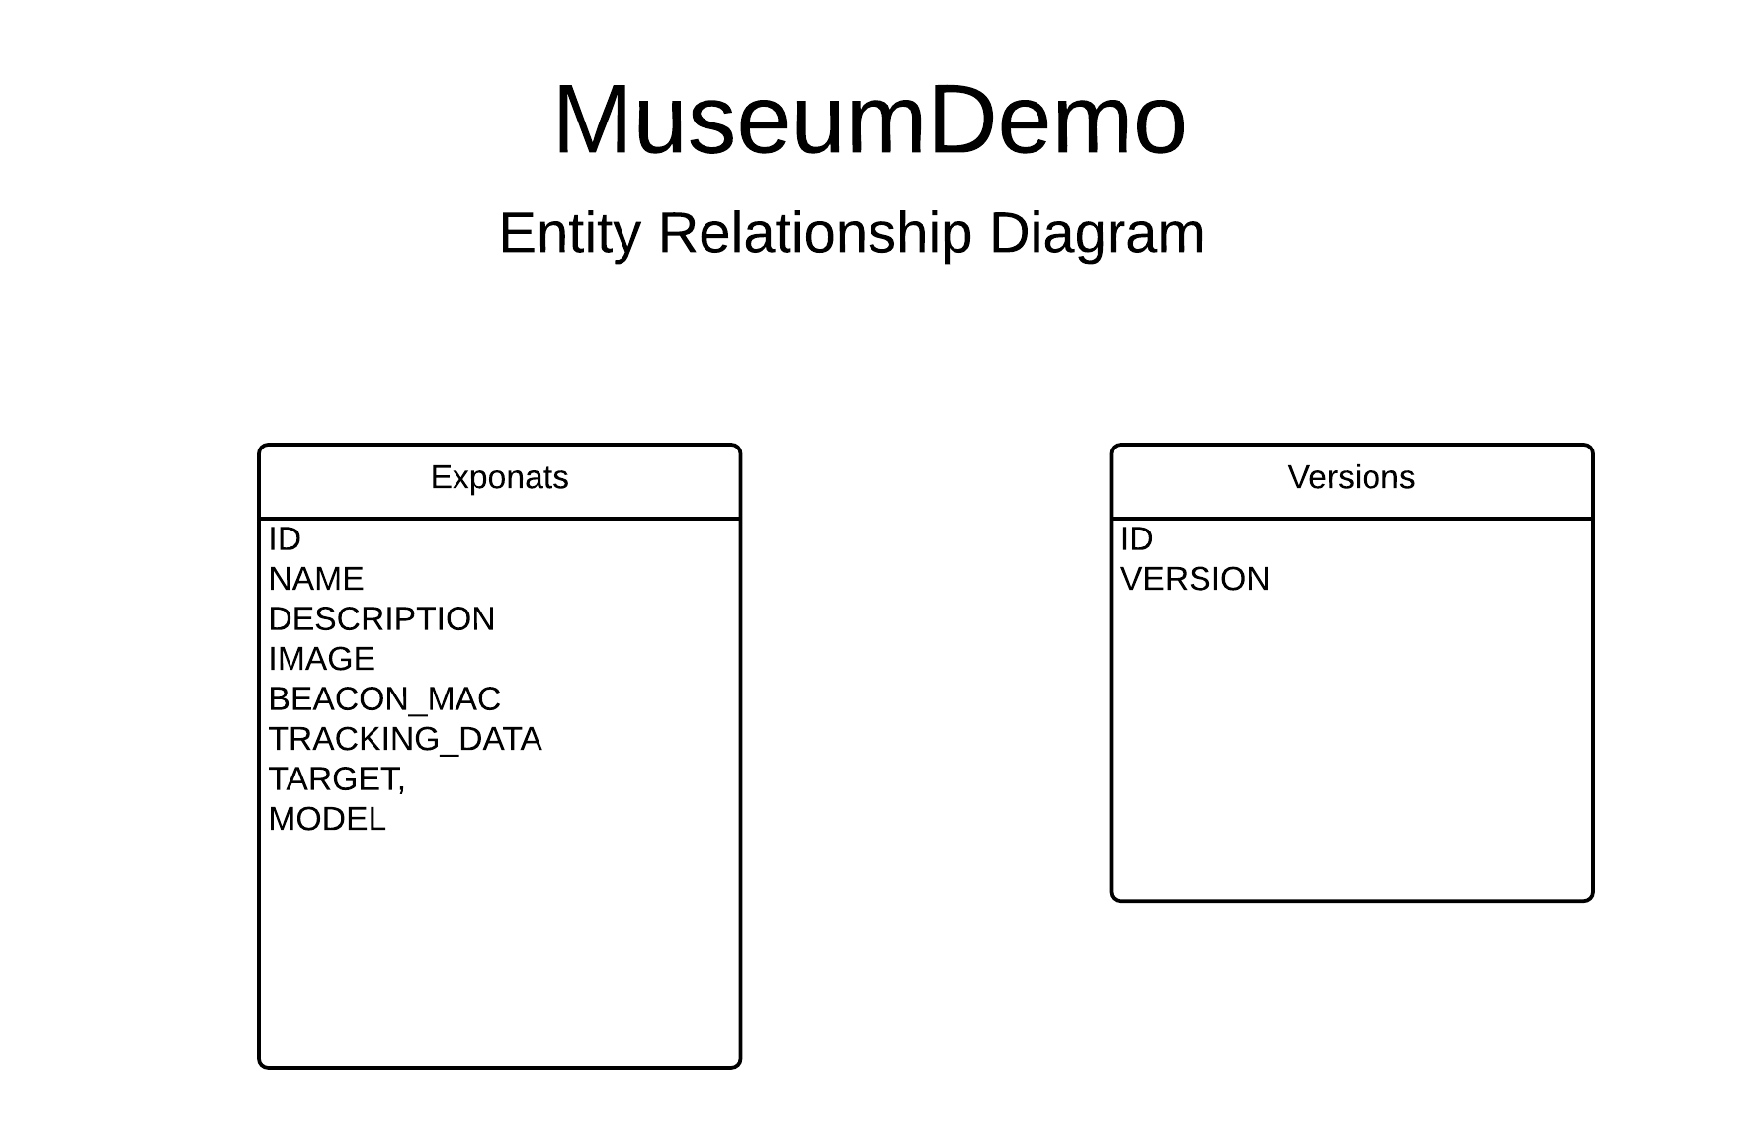
Figure 3. Entity Relationship Diagram Museum Demo

Mobile Application Activities
Application consists of three Activity Screens.

ListBeaconsActivity
As shown on Figure 4. the Activity provides a list of the exponats available in the museum and an estimated distance to them. The exponats are matched to the museum by the following characteristics: Name, Description, Image, Mac address of the iBeacon.
The list of the beacons changes periodically ordered by the distance.
This activity is responsible for checking whether the version of the file is updated on the server side and performs the update in case of new version.


Figure 4. List Beacons Activity

Distance Beacon Activity
As shown on Figure 5. the Activity provides guidance towards the beacon. When the user approaches the beacon inside the set distance (currently set to 0.80 meters) the next activity is triggered.
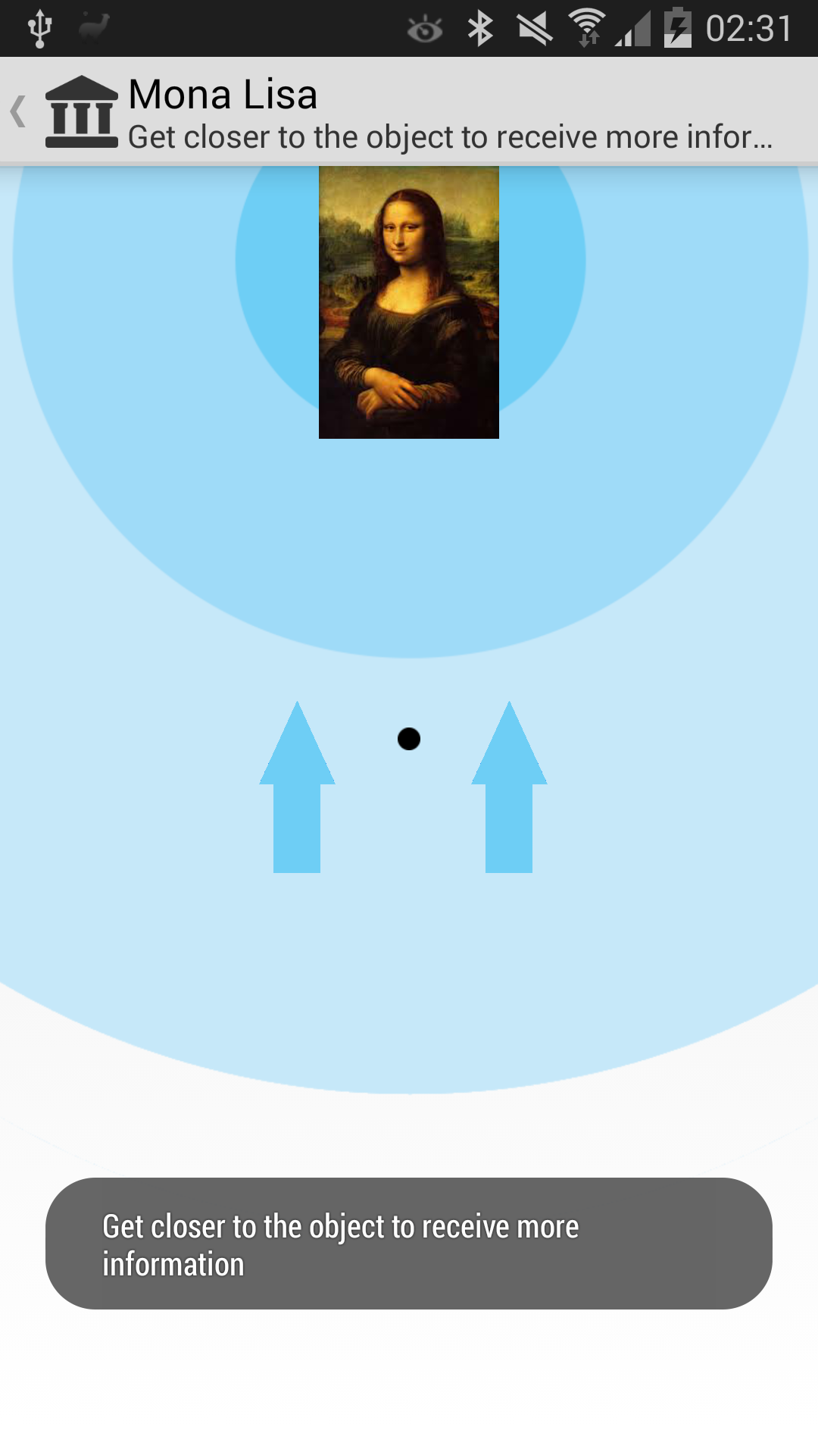
Figure 5.Distance Beacon Activity

Metaio Activity
As shown on Figure 6. the Activity handles the augmented reality matched to the current exponats.

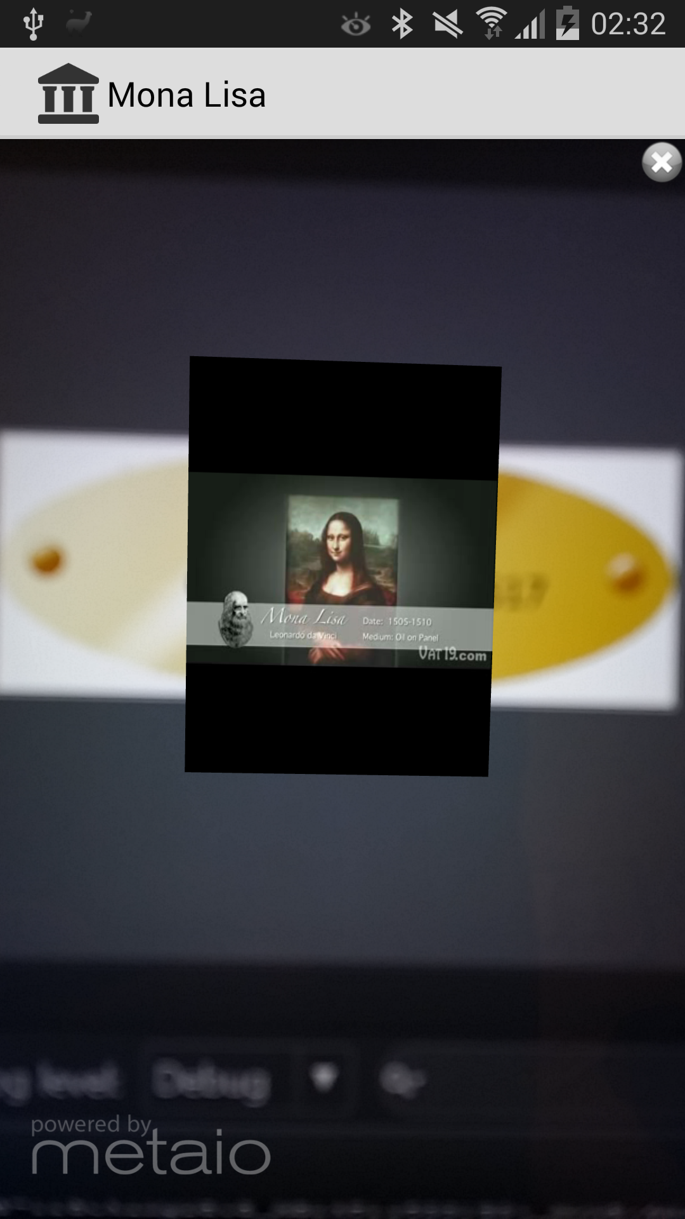
Figure 6. Metaio Activity

Software Design

Design technologies
Based on the project requirements the application was developed on Android using Android Studio v.1.0.2. The project was developed using Distributed version control technology - GitHub. The repository for the project is developed in https://github.com/PaLaMuNDeR/MuseumDemo [3].

Data flow Diagram
The data flow is described on Figure 7. First the data is retrieved from the Server side, then the files are stored on the internal memory on the phone, the data is stored on DB inside the application. And the data is passed to the client – visual part.
.
Application Server

Mobile Application

Internal Memory
Database
Client part

Figure 7. Data Flow Diagram

References:

[1] Estimote SDK – https://github.com/Estimote/Android-SDK
[2] Metaio SDK - http://ar.metaio.com/download_sdk
[3] MuseumDemo - https://github.com/PaLaMuNDeR/MuseumDemo

